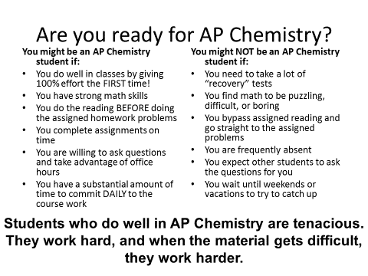

If you have any questions or concerns, please see Ms. Nock or Ms. Hays

